Integrate Zscaler with Identity Providers
(IdPs) such as Azure AD, Okta, and Active
Directory for seamless authentication and authorization.

TEAM DETAILS

College: KPR College of Arts Science and Research
College Code: bruaz

S. No | Name | Register No. | Email
1 | Taruni A S | 2322K0278 | 23bcs063@kprcas.ac.in
2 | Thanushree S | 2322K079 | 23bcs064@kprcas.ac.in
3 | Exalina A | 2322K0235 | 23bcs021@kprcas.ac.in
4 | Akashy Keerthi S | 2322K0219 | 23bcs005@kprcas.ac.in

Project details

Title:

Integrate Zscaler with Identity Providers (IdPs) such as Azure AD, Okta, and Active Directory for seamless authentication and authorization.

This project describes the approach and implementation process for integrating the Zscaler security platform with the organization’s primary Identity Providers (IdPs), including Microsoft Entra ID (Azure AD), Okta, and on-premises Active Directory (AD). The main goal of this integration is to establish a secure and efficient system for user authentication and authorization across all Zscaler services.

Instead of managing users through separate local accounts, the project focuses on using centralized identity platforms to build a Zero Trust security framework, where access is continuously validated based on user identity and contextual factors. This approach ensures that authentication is handled through a single trusted identity source while applying consistent security measures such as Multi-Factor Authentication (MFA).

In addition, the integration enhances the user experience by enabling Single Sign-On (SSO), allowing users to access services more conveniently and securely. Overall, this solution connects the organization’s identity management infrastructure with its security enforcement system, ensuring that authorized users receive the appropriate level of secure access to the internet and applications from any location.

Abstract:

This project explains the integration of the Zscaler Internet security platform with major Identity Providers (IdPs) such as Microsoft Entra ID (Azure AD), Okta, and on-premises Active Directory (AD). The main goal of this project is to create a unified identity management system that enables Single Sign-On (SSO) and centralized authorization for all Zscaler services. By using trusted organizational identity directories, this system removes the need for multiple user credentials and supports the implementation of a modern Zero Trust security architecture.

Through the use of standard authentication protocols such as SAML, OIDC, and SCIM, the system allows user authentication to be handled by trusted identity providers while maintaining consistent security policies like Multi-Factor Authentication (MFA). This method improves the user experience by minimizing the need for multiple passwords and also increases the organization’s security by ensuring that every access request is verified by the identity provider before reaching the Zscaler security platform.
In addition, automated user provisioning using SCIM simplifies user lifecycle management, which helps reduce administrative workload and improves overall security management. As a result, this integration creates a strong identity-based security model that follows Zero Trust principles, ensuring that only verified and authorized users can securely access internet and cloud-based applications from any location. This solution connects identity management with network security, enabling a flexible and efficient access control system.

Use Case Scenario 1:
Remote Faculty Access to Research Data
A research professor attending a conference outside the campus needs secure access to confidential research files stored on an internal server. Instead of connecting to the entire campus network using VPN, Zscaler Private Access (ZPA) allows the professor to access only the required research server. The professor authenticates through the university’s identity provider, and permissions are granted according to the user’s role.
Output:
• User identity verified: Research_Faculty_Group
• Context-aware access enforced: Access permitted only from off-campus IP addresses
• Connection restricted: Access limited to the Research File Server (R&D_Server)
• Security enforcement: Multi-Factor Authentication (MFA) required due to remote access
• No lateral movement: User cannot access other internal systems such as HR or student databases

Use Case Scenario 2: Student Access to Online Learning Portal
A student wants to access the university’s online learning portal from home. Instead of managing multiple login credentials, the student signs in using the university identity provider through Single Sign-On (SSO) integrated with Zscaler. The system verifies the user’s identity and allows access only to the learning portal.
Output:
• User identity verified: Student_User_Group
• Single Sign-On enabled: Student logs in using university credentials via Azure AD
• Application-level access: Access restricted to the Learning Management System (LMS_Portal)
• Security enforcement: Identity verified before granting access
• Restricted permissions: Student cannot access faculty or administrative resources

Use Case Scenario 3: IT Administrator Managing Secure Network Access
An IT administrator needs to manage internal applications and monitor network access from the campus office. The administrator logs in through the organization’s identity provider (Active Directory), and Zscaler grants elevated access privileges according to the admin role.
Output:
• User identity verified: IT_Admin_Group
• Role-based access control: Administrator privileges granted for management tools
• Secure authentication: Access authenticated through Active Directory integration
• Security monitoring: Administrative activities logged and monitored
• Controlled access: Admin privileges restricted to authorized systems only

Use Case Scenario 4: Employee Access to Cloud Applications
A university employee working remotely needs access to cloud-based applications such as email and document management. By integrating Okta with Zscaler, the employee can securely access these applications through SSO without remembering multiple passwords.
Output:
• User identity verified: Employee_Group
• Single Sign-On enabled: Authentication performed through Okta
• Secure cloud access: Access granted to approved cloud applications
• Security enforcement: Multi-Factor Authentication required for login
• Access limitation: Unauthorized applications are blocked automatically

Use Case Scenario 5: New Employee Automatic Account Provisioning
When a new employee joins the organization, their account is automatically created and synchronized across systems using SCIM provisioning. Once the account is added to the identity provider, Zscaler automatically assigns the correct access permissions based on the employee’s role.
Output:
• User identity created: New employee account added to Identity Provider
• Automatic provisioning: SCIM synchronizes user details with Zscaler
• Role-based access: Permissions assigned according to job role
• Security enforcement: Access granted only after successful authentication
• Lifecycle management: Access removed automatically when employee leaves the organization

Stage-1

Title Of the Project:
Integrate Zscaler with Identity Providers (IdPs) such as Azure AD, Okta, and Active Directory for seamless authentication and authorization.

Overview:

Modern digital systems face an increasing number of cybersecurity threats due to the rapid growth of cloud computing, remote work environments, and interconnected applications. Traditional security architectures relied on perimeter-based models that assumed users inside a corporate network were trustworthy once authenticated through mechanisms such as Virtual Private Networks (VPNs). However, this model has become ineffective as attackers frequently exploit stolen credentials, misconfigured systems, and vulnerable applications to gain unauthorized access. To address these challenges, modern security frameworks integrate principles from both Zero Trust Network Access (ZTNA) and secure application development standards promoted by organizations such as OWASP. OWASP is a global nonprofit community focused on improving software security by providing open resources, tools, and guidelines that help organizations build, deploy, and maintain secure applications. Its well-known OWASP Top 10 identifies the most critical web application vulnerabilities and serves as a global awareness standard for developers and security professionals. These vulnerabilities include issues such as broken access control, cryptographic failures, injection attacks, and security misconfiguration, which are among the most common causes of data breaches and system compromises.

In parallel, Zero Trust Network Access represents a modern cybersecurity architecture designed to eliminate the weaknesses of traditional network-based trust models. Instead of granting users full access to internal networks after authentication, ZTNA enforces the principle of “never trust, always verify” by validating every access request based on user identity, device security posture, and contextual information such as location and behavior. In a ZTNA environment, users are connected directly to specific applications rather than the entire corporate network, which significantly reduces the attack surface and prevents attackers from moving laterally across systems if an account becomes compromised. The integration of ZTNA with secure development practices aligned with OWASP recommendations creates a robust security ecosystem where both network access control and application-level protection work together to defend against cyber threats.

The working process in a Zero Trust–based architecture begins when a user attempts to access an application hosted either in a cloud platform or within a private enterprise environment. The system first verifies the identity of the user through authentication services such as Single Sign-On or Multi-Factor Authentication. After identity verification, the security framework evaluates the device posture by checking system updates, endpoint protection status, and compliance with organizational policies. Once these checks are completed, an access policy engine analyzes contextual parameters including user role, risk score, and access location. If the request satisfies

all security requirements, a secure encrypted micro-tunnel is created between the user and the specific application without exposing the internal network. Throughout the session, the system continuously monitors user behavior to detect anomalies, automatically blocking access if suspicious activity occurs. This approach ensures that users only interact with the resources they are authorized to access while keeping the underlying network infrastructure invisible to unauthorized entities.

By combining the application security principles promoted by OWASP with the identity-centric access control model of ZTNA, organizations can significantly strengthen their cybersecurity posture. OWASP guidelines help developers design secure software and reduce vulnerabilities within applications, while ZTNA protects the infrastructure by controlling how users connect to those applications. This layered security strategy mitigates risks such as credential theft, phishing attacks, insider threats, and unauthorized data exposure. As enterprises increasingly adopt cloud services, remote work models, and distributed systems, integrating OWASP-based secure coding practices with Zero Trust Network Access provides a scalable and resilient approach to protecting sensitive resources and ensuring secure digital interactions across modern IT environments.
List of Vulnerability Table:

S. No. | Vulnerability Name | CWE Number
1 | Relative Path Traversal | CWE-23
2 | Active Debug Code | CWE-489
3 | Software Supply Chain Compromise | CWE-829
4 | Weak Cryptographic Implementation | CWE-327
5 | SQL Injection in Hibernate Queries | CWE-564
6 | Missing Encryption of Sensitive Data | CWE-311
7 | Use of Hard-coded Password | CWE-259
8 | Inclusion of Functionality from Untrusted Control Sphere | CWE-829
9 | Improper Output Neutralization for Logs (Log Injection) | CWE-117
10 | NULL Pointer Dereference | CWE-476

REPORT: -

Vulnerability Name: Relative Path Traversal

CWE- 23

OWASP Category: A01:2021 – Broken Access Control

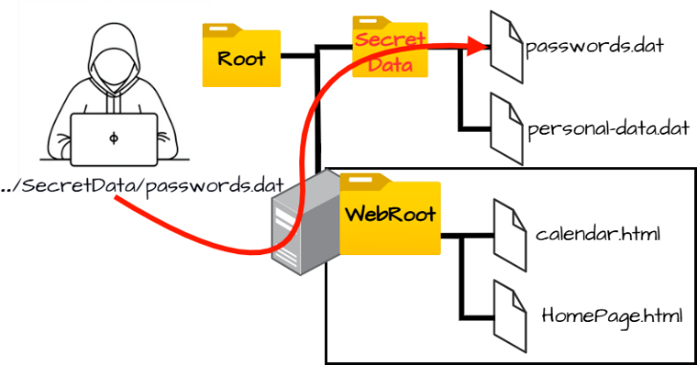
Description: Relative Path Traversal occurs when an application constructs file paths using user input without proper validation, allowing attackers to manipulate directory sequences like “../”, which enables them to move outside the intended directory and access sensitive files on the server.
Business Impact: Attackers can gain unauthorized access to confidential system files, configuration data, or credentials, which may lead to data breaches, system compromise, operational disruption, and significant financial and reputational damage to the organization.

Recommendation:
- Input Validation: Validate and sanitize all user inputs used in file paths and allow only predefined safe values.
- Path Canonicalization: Normalize and verify file paths to remove traversal sequences such as “../” before accessing files.
- Access Control Restrictions: Restrict file access to specific directories and enforce strict file permissions to prevent unauthorized file access.

Vulnerability Name: Active Debug Code

CWE-489

OWASP Category: A02:2021 – Security Misconfiguration

Description: Active Debug Code occurs when a software product is released with debugging or testing code still enabled in the production environment, which can expose internal application behavior and create unintended entry points for attackers, potentially allowing them to manipulate application functions or bypass security controls.
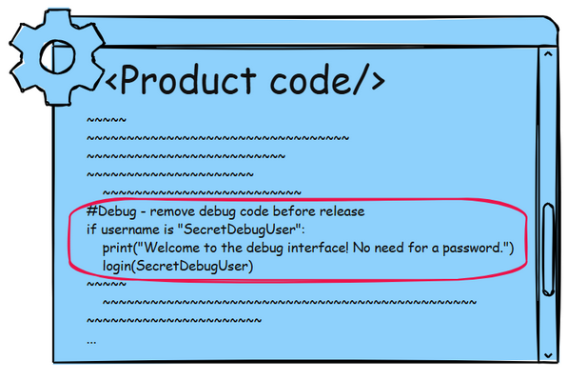
Business Impact: If debug functionality remains active in a deployed system, attackers may exploit it to access sensitive application data, bypass authentication mechanisms, or gain elevated privileges, which could ultimately lead to full compromise of the application or underlying server infrastructure.

Recommendation:

- Remove Debug Code Before Deployment: Ensure that all debugging functions, testing endpoints, and development backdoors are completely removed or disabled before deploying the application to production environments.
- Implement Secure Configuration Management: Adopt strict configuration management practices to ensure that debug modes, logging levels, and development settings are not enabled in production systems.
- Perform Security Testing and Code Review: Conduct static code analysis, penetration testing, and security reviews to detect leftover debug code and other insecure development artifacts before releasing the application.

Vulnerability Name: Software Supply Chain Compromise

CWE-829

OWASP Category: A03:2025 – Software Supply Chain Failures

Description: Software supply chain failures occur when an application relies on third-party libraries, dependencies, or components that contain vulnerabilities or malicious code, which can compromise the security of the entire system.
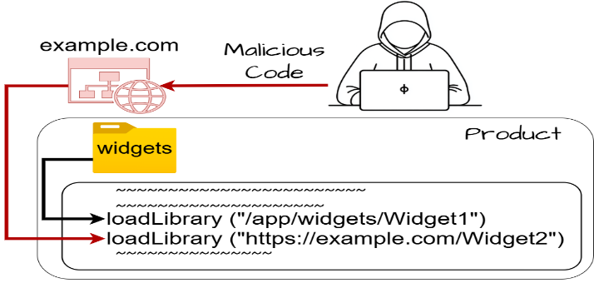
Business Impact: Attackers may inject malicious code through compromised dependencies, leading to system compromise, data theft, and large-scale attacks affecting multiple organizations.

Recommendation:

- Dependency Verification: Use trusted repositories and verify the integrity of third-party libraries before including them in the application.
- Regular Dependency Updates: Continuously update and patch third-party components to reduce exposure to known vulnerabilities.
- Supply Chain Monitoring: Use automated tools to scan and monitor software dependencies for security risks.

- Vulnerability Name: Weak Cryptographic Implementation

CWE - 327

OWASP Category: A04:2025 – Cryptographic Failures

Description: Cryptographic failures occur when sensitive data is protected using weak encryption algorithms, improper key management, or insecure transmission mechanisms.
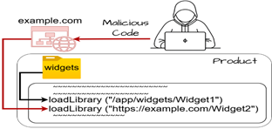
Business Impact: Weak encryption may allow attackers to decrypt confidential data such as passwords, financial information, or personal records.

Recommendation:
- Use Strong Encryption: Implement modern encryption standards such as AES-256 and TLS 1.3 to secure sensitive data.
- Secure Key Management: Store cryptographic keys securely and rotate them periodically to prevent misuse.
- Encrypt Sensitive Data: Ensure that all sensitive data is encrypted both in transit and at rest.

Vulnerability Name: SQL Injection in Hibernate Queries
CWE-564
OWASP Category: A05:2025 – Injection
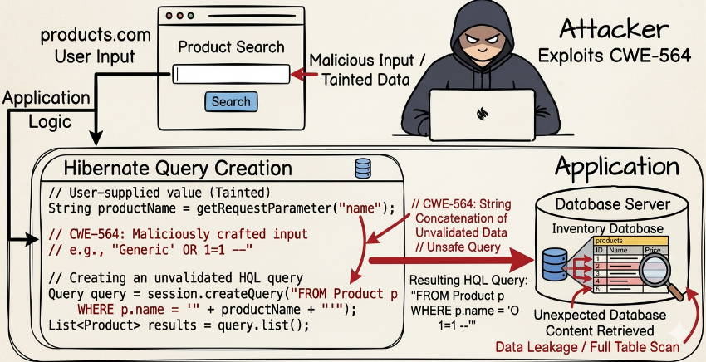
Description: SQL Injection in Hibernate occurs when an application builds Hibernate Query Language (HQL) statements using unvalidated user input, allowing attackers to manipulate the query structure and execute unauthorized database commands through the Hibernate framework.

Business Impact: Attackers may retrieve, modify, or delete sensitive database records, potentially leading to data breaches, unauthorized access to user information, and compromise of the entire application database.
Recommendation:
- Use Parameterized Queries: Always use parameter binding in Hibernate queries to prevent user input from being interpreted as executable query code.
- Input Validation: Validate and sanitize all user inputs before using them in HQL queries to ensure that malicious characters or commands are rejected.
- Least Privilege Database Access: Configure database accounts with minimal privileges so that even if an injection occurs, the attacker cannot perform critical operations.

Vulnerability Name: Missing Encryption of Sensitive Data

CWE – 311

OWASP Category: A04:2025 – Cryptographic Failures
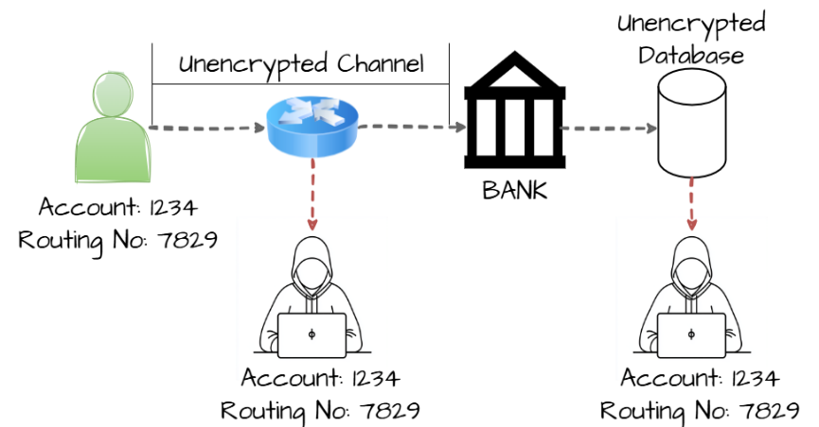
Description: This vulnerability occurs when sensitive information such as passwords, personal data, or financial details is stored or transmitted without proper encryption, making it accessible to unauthorized parties who may intercept or access the data.

Business Impact: Attackers may capture or read sensitive data through network interception or unauthorized system access, which can lead to data breaches, identity theft, financial loss, and reputational damage for the organization.

Recommendation:

- Encrypt Sensitive Data: Use strong encryption algorithms such as AES or TLS to protect sensitive data during storage and transmission.
- Secure Communication Channels: Ensure that all data exchanges occur over secure protocols like HTTPS instead of insecure protocols such as HTTP.
- Proper Key Management: Store and manage encryption keys securely and rotate them periodically to prevent unauthorized access.

Vulnerability Name: Use of Hard-coded Password

CWE- 259

OWASP Category: A07- 2025 – Authentication Failures

Description: This vulnerability occurs when a password is directly embedded in the application source code or configuration files, allowing anyone who gains access to the code to easily discover and use the credentials to access the system.
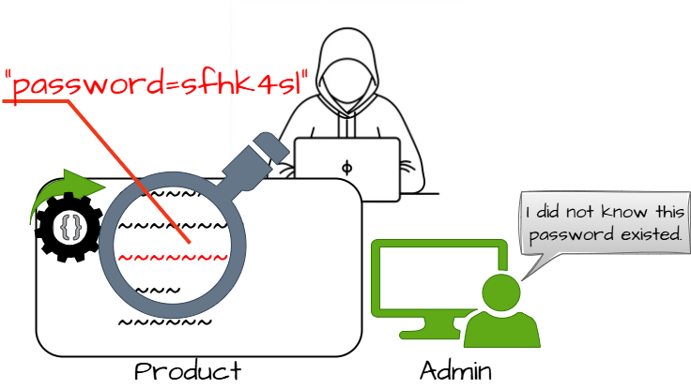
Business Impact: Attackers who obtain the hard-coded password may gain unauthorized access to applications, databases, or administrative functions, potentially leading to data breaches, system compromise, and loss of sensitive information.

Recommendation:

- Use Secure Credential Storage: Store passwords securely using environment variables or dedicated secret management systems instead of embedding them in source code.
- Implement Strong Authentication: Use secure authentication mechanisms such as token- based authentication or multi-factor authentication to reduce reliance on static passwords.
- Regular Credential Rotation: Frequently change passwords and remove hard-coded credentials from the application to minimize the risk of unauthorized access.

Vulnerability Name: Inclusion of Functionality from Untrusted Control Sphere

CWE- 829

OWASP Category: A03:2025 – Software Supply Chain Failures

Description: This vulnerability occurs when an application loads or executes code from external or untrusted sources without proper validation, which may allow attackers to introduce malicious components into the system.

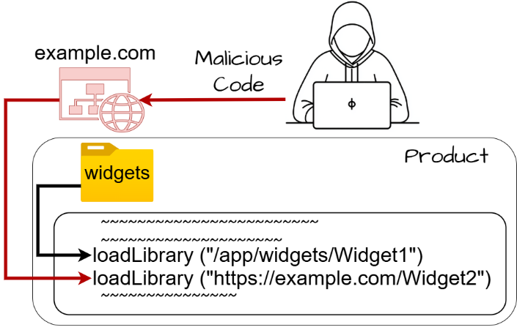
Business Impact: Attackers can inject malicious libraries or scripts into the application, leading to unauthorized code execution, system compromise, or large-scale supply chain attacks affecting multiple systems.

Recommendation:

- Validate External Sources: Ensure all external libraries and modules are obtained from trusted repositories and verified before use.
- Implement Integrity Checks: Use digital signatures or hash verification to confirm that external components have not been tampered with.
- Limit External Code Execution: Restrict the application from dynamically loading code from unknown or untrusted sources.

Vulnerability Name: Improper Output Neutralization for Logs (Log Injection)

CWE- 117

OWASP Category: A09:2025 – Security Logging and Alerting Failures
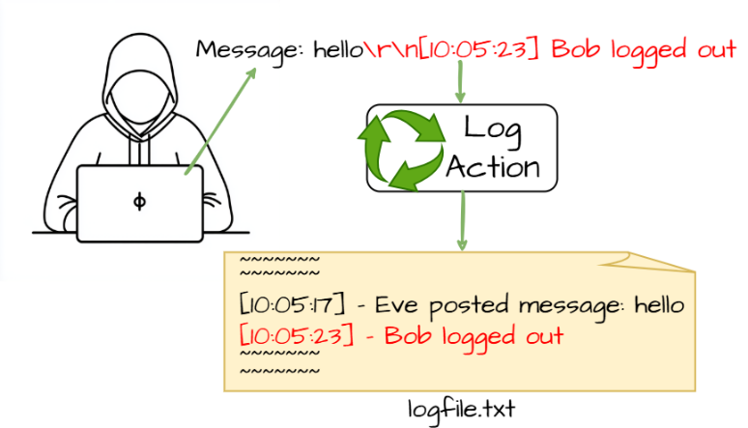
Description: This vulnerability occurs when user-controlled input is written directly to log files without proper sanitization, allowing attackers to manipulate log entries or inject malicious content.

Business Impact: Attackers can alter or forge log records, hide malicious activities, or inject misleading information, which may disrupt security monitoring and incident investigations.

Recommendation:

- Sanitize Log Inputs: Filter or encode user input before writing it to log files to prevent injection attacks.
- Use Structured Logging: Implement standardized logging formats that prevent manipulation of log entries.

- Protect Log Integrity: Restrict access to log files and implement monitoring to detect unauthorized changes.

10) Vulnerability Name: NULL Pointer Dereference

CWE- 476

OWASP Category: A10:2025 – Mishandling of Exceptional Conditions

Description: This vulnerability occurs when a program attempts to access or dereference a pointer that has a NULL value, which may cause the application to crash or behave unpredictably.
Business Impact: Exploiting this vulnerability may result in system crashes, denial of service, or instability of the application, affecting availability and reliability of the system.
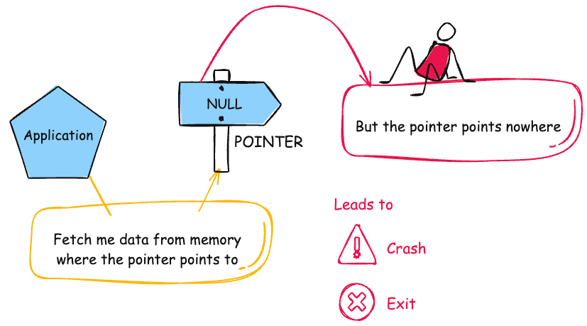
Recommendation:

1. Validate Pointers Before Use: Always check whether a pointer is NULL before accessing it in the program.
2. Implement Proper Exception Handling: Use error handling mechanisms to manage unexpected conditions safely.
3. Perform Secure Code Reviews: Conduct regular code reviews and testing to detect and fix potential NULL pointer issues.

Stage 2

Title:
Integrate Zscaler with Identity Providers (IdPs) such as Azure AD, Okta, and Active Directory for seamless authentication and authorization
overview:-
Integrating Zscaler with Identity Providers (IdPs) such as Microsoft Entra ID (Azure AD), Okta, and on-premises Active Directory enables secure, seamless, and identity-centric access to organizational applications. This approach enforces Zero Trust Network Access (ZTNA) principles, ensuring every user and device is verified before access is granted.
In this model, access decisions are based on identity rather than network location. When a user attempts to access an application, Zscaler redirects the authentication request to the configured IdP, which validates credentials via secure mechanisms like Single Sign-On (SSO) and Multi-Factor Authentication (MFA).
After successful authentication, Zscaler enforces granular access policies based on user role, device posture, and organizational rules. Users are granted access only to the applications they are authorized for, protecting sensitive resources while simplifying management. Protocols like SAML, OpenID Connect (OIDC), and LDAP ensure secure communication between Zscaler and IdPs, centralizing user provisioning, authentication, and policy enforcement.
Operationally, this integration reduces administrative overhead by automating user lifecycle management using SCIM-based provisioning. Administrators can manage user accounts, group memberships, and access policies from a single identity platform, while ensuring immediate deprovisioning when users leave the organization. This automation not only improves security but also enhances compliance by maintaining an auditable record of user access and authentication events.
Looking forward, integrating Zscaler with IdPs provides a foundation for advanced security initiatives. Organizations can implement adaptive access policies that respond to real-time risk factors, integrate with endpoint security solutions for device posture verification, and extend Zero Trust principles to branch offices, remote workers, and cloud applications. This future-ready architecture strengthens the enterprise’s security posture while providing a seamless, low-latency experience for all users.

Here is a step-by-step explanation of how the integration works:

- When a user attempts to access an application, the request first goes through the Zscaler security platform.
- Zscaler redirects the authentication request to the configured Identity Provider such as Microsoft Entra ID, Okta, or Active Directory.
- The Identity Provider verifies the user’s credentials using authentication methods such as Single Sign-On (SSO) or Multi-Factor Authentication (MFA).
- After successful authentication, the Identity Provider sends a confirmation to Zscaler.
- Zscaler then checks the organization’s access policies and determines whether the user is authorized to access the requested application.
- If the user meets all security requirements, Zscaler establishes a secure connection between the user and the specific application.
This integration allows organizations to provide secure and seamless access to applications while ensuring that authentication and authorization are centrally managed.
Importance of Zscaler–IdP Integration

Integrating Zscaler with Identity Providers helps organizations strengthen their Zero Trust security model. It ensures that users are authenticated through trusted identity platforms before they can access applications or resources.
This approach simplifies identity management, improves security, and enhances the overall user experience.

Benefits of Zscaler–IdP Integration

● Strong Authentication: Identity Providers verify user identity using secure methods such as Single Sign-On and Multi-Factor Authentication.
● Centralized Identity Management: User accounts, permissions, and authentication policies can be managed from a single identity platform.
● Improved Security: Access to applications is granted only after verifying user identity, device status, and security policies.
● Scalability: The integration supports organizations of different sizes and can handle large numbers of users and applications.
● Seamless User Experience: Users can securely access multiple applications using a single login process.
● Flexible Integration: Zscaler supports integration with multiple identity providers such as Microsoft Entra ID, Okta, and Active Directory.

Target website :- zero.webappsecurity.com
Target ip address:- 54.82.22.241

List of vulnerability:-

s.no | Vulnerability name | Severity | plugins
1 | Weak Password Authentication | HIGH | 200101
2 | TLS Version 1.1 supported | MEDIUM | 200102
3 | SSL/TLS weak cipher suites | LOW | 200103
4 | Missing HSTS on Zscaler access port | MEDIUM | 200104
5 | Insecure SCIM /Provisioning Endpoint | HIGH | 200105
6 | Missing Multi-Factor Authentication (MFA) | HIGH | 200106
7 | SAML Assertion Replay Risk | MEDIUM | 200107
8 | User Role Misconfiguration | MEDIUM | 200108
9 | Device Posture Not Verified | LOW | 200109
10 | Excessive Session Duration | LOW | 200110

REPORT: -

1) Vulnerability Name: - 200101- Weak Password Authentication
Severity: - HIGH
Plugin: - 200101
Port: - 443 (or applicable login/service port)
Description: - The system is configured with weak user authentication mechanisms, allowing access through easily guessable passwords, default credentials, or insufficient verification methods. Such weak authentication significantly increases the risk of unauthorized access to sensitive applications and data. Attackers could exploit these weaknesses to gain administrative privileges, compromise confidential information, or move laterally across the network. Organizations relying on weak authentication face a higher likelihood of security breaches and potential exposure of critical resources.
Solution: - Implement strong password policies enforcing complexity, length, and periodic changes. Enable Multi-Factor Authentication (MFA) for all accounts to provide an additional verification layer. Remove default and shared credentials and ensure all users have unique accounts. Regularly review and disable inactive or unnecessary accounts. Educate users on secure authentication practices and the risks of password reuse or social engineering attacks.
Business Impact: - Continued reliance on weak authentication exposes the organization to severe security risks, including unauthorized access to sensitive data, regulatory non-compliance (e.g., PCI DSS, ISO 27001), and potential financial or reputational damage. Exploitation of weak credentials could lead to data breaches, disruption of business operations, and loss of customer trust. Addressing this vulnerability is critical to strengthening the organization’s security posture and ensuring the confidentiality, integrity, and availability of enterprise resources.

2) Vulnerability Name: - 200102 - TLS Version 1.1 Supported
Severity: - MEDIUM
Plugin: - 200102

Port: - 443 (or relevant application port)
Description: - The system currently supports TLS 1.1, an outdated encryption protocol that lacks compatibility with modern cipher suites and secure encryption modes. In a Zero Trust Network Access (ZTNA) architecture using Zscaler integrated with Identity Providers like Azure AD, Okta, or Active Directory, TLS 1.1 support introduces risks to the secure authentication and authorization flows. Attackers could exploit the weaker encryption to intercept credentials, authentication tokens, or sensitive application data during transit. This compromises the integrity of Single Sign-On (SSO), Multi-Factor Authentication (MFA), and identity-based access controls enforced by Zscaler.
Solution: - Disable TLS 1.1 and ensure all communication between users, endpoints, Identity Providers, and Zscaler cloud services uses TLS 1.2 or TLS 1.3. Update any Zscaler App Connectors, servers, and client applications to enforce modern TLS protocols.
Business Impact: - Allowing TLS 1.1 connections in a Zscaler-enabled Zero Trust environment increases the risk of unauthorized access and data interception. It may lead to breaches of sensitive application data and weaken enforcement of identity-centric access controls. Additionally, endpoints and cloud services that do not support TLS 1.2 or higher may face compatibility issues, causing disrupted access for users. Remediating this vulnerability ensures secure, encrypted connections for all users, maintains compliance with regulatory standards, and preserves trust in enterprise security infrastructure.

3) Vulnerability Name: - 200103 - SSL/TLS Weak Cipher Suites
Severity: - LOW
Plugin: - 200103

Port: - 443 (or relevant application port)
Description: - The system currently allows SSL/TLS connections using weak cipher suites that do not meet modern cryptographic standards. In a Zscaler-enabled Zero Trust Network Access (ZTNA) environment integrated with Identity Providers like Azure AD, Okta, or Active Directory, supporting weak cipher suites introduces potential vulnerabilities in authentication and data transmission. Attackers could exploit these weak ciphers to decrypt sensitive data, compromise session integrity, or interfere with secure communication between users, Zscaler services, and enterprise applications.
Solution: - Reconfigure all SSL/TLS-enabled services, Zscaler App Connectors, and endpoints to use only strong cipher suites such as AES with GCM, ChaCha20, or other recommended modern encryption algorithms. Disable all weak ciphers like 3DES, RC4, or export-grade ciphers to ensure secure connections.
Business Impact: - Supporting weak cipher suites increases the risk of data interception, credential compromise, and unauthorized access in a Zero Trust architecture. Although the severity is classified as low, failing to remediate this issue could lead to the exposure of sensitive enterprise data or the weakening of identity-based access controls. Updating to strong cipher suites ensures the confidentiality and integrity of user-to-application connections, maintains compliance with security standards, and reinforces trust in the organization’s secure access framework.

4) Vulnerability Name: - - 200104 - Missing HSTS on Zscaler Access Port
Severity: - MEDIUM
Plugin: - 200104

Port: - 443 (Zscaler access port)
Description: - HTTP Strict Transport Security (HSTS) is not enabled on the Zscaler access port. Without HSTS, web browsers connecting to Zscaler services may be vulnerable to protocol downgrade attacks and cookie hijacking. In a Zero Trust Network Access (ZTNA) setup integrated with Identity Providers like Azure AD, Okta, or Active Directory, missing HSTS could allow an attacker to intercept or manipulate authentication traffic, potentially compromising secure access to enterprise applications.
Solution: - Enable HSTS on the Zscaler access port by configuring the Strict-Transport-Security HTTP header with an appropriate max-age value and include subdomains if applicable. This ensures browsers enforce HTTPS connections and protect the integrity and confidentiality of user authentication sessions.
Business Impact: - Failing to implement HSTS on Zscaler access ports increases the risk of man-in-the-middle attacks and session hijacking during authentication. Although the severity is medium, it could undermine the security of identity-based access controls and compromise sensitive enterprise resources. Enabling HSTS reinforces secure user-to-application connectivity, aligns with best practices for Zero Trust security, and enhances user trust in the organization’s secure access framework.

5) Vulnerability Name: -200105 - Insecure SCIM / Provisioning Endpoint
Severity: - HIGH
Plugin: - 200105

Port: - 443 (Zscaler SCIM/Provisioning endpoint)
Description: - The SCIM/provisioning endpoint for Zscaler user and group management is insecure, potentially allowing unauthorized access or manipulation of user accounts. SCIM endpoints are used to automate user lifecycle management from Identity Providers such as Azure AD, Okta, or Active Directory. If this endpoint is improperly secured, an attacker could intercept or modify provisioning requests, create unauthorized accounts, or escalate privileges within the enterprise Zero Trust access environment.
Solution: - Secure the SCIM/provisioning endpoint by enforcing HTTPS with strong TLS versions (1.2 or higher), requiring authentication tokens or API keys, and restricting access to only trusted Identity Providers. Regularly audit API logs to monitor unusual provisioning activity and ensure all tokens and credentials are rotated periodically.
Business Impact: - An insecure SCIM/provisioning endpoint poses a critical risk to enterprise security. Compromise of this endpoint could allow unauthorized user creation, modification, or deletion, undermining identity-based access policies enforced through Zscaler and connected Identity Providers. Exploitation may lead to unauthorized access to sensitive applications, data exposure, and potential regulatory non-compliance. Securing this endpoint is essential to maintain the integrity of automated user provisioning and the overall security of the Zero Trust network.

.

6) Vulnerability Name: -200106 - Missing Multi-Factor Authentication (MFA)
Severity: - HIGH
Plugin: - 200106

Port: - 443 (Zscaler authentication endpoint)
Description: - The Zscaler user authentication process does not enforce Multi-Factor Authentication (MFA) for user logins. MFA is a critical security control that requires users to provide additional verification, such as a one-time password or authentication app, in addition to their password. Without MFA, accounts are solely protected by passwords, which can be compromised through phishing, credential stuffing, or brute-force attacks, increasing the risk of unauthorized access to enterprise applications and sensitive data.
Solution: - Implement and enforce MFA for all users accessing Zscaler services. Configure MFA through integrated Identity Providers such as Azure AD, Okta, or Active Directory. Ensure that MFA policies are applied consistently across all critical applications, including Zscaler Private Access (ZPA) and Zscaler Internet Access (ZIA). Regularly review MFA logs and alerts to detect failed or suspicious authentication attempts.
Business Impact: - The absence of MFA significantly increases the risk of account compromise and unauthorized access to organizational resources. Exploitation of this vulnerability could allow attackers to bypass identity-based security controls, potentially exposing sensitive applications and data. Implementing MFA is essential to strengthen the Zero Trust access model, reduce the likelihood of security breaches, and maintain compliance with security policies and regulatory requirements.

7) Vulnerability Name: -200107 - SAML Assertion Replay Risk
Severity: - MEDIUM
Plugin: - 200107

Port: - 443 (Zscaler SAML authentication endpoint)
Description: - The Zscaler SAML integration with Identity Providers (IdPs) is potentially susceptible to assertion replay attacks. In such attacks, a valid SAML assertion captured by an attacker could be reused to gain unauthorized access to enterprise applications. This risk arises when SAML responses are not properly time-bound, lack unique identifiers, or are not validated for one-time use by the service provider. Exploitation could allow an attacker to impersonate a legitimate user without needing their credentials.
Solution: - Configure the Identity Provider and Zscaler to enforce strict SAML security measures, including validating assertion timestamps, enforcing one-time usage of assertions, and verifying signature integrity. Ensure that replay detection mechanisms are enabled, and consider implementing short assertion lifetimes to reduce the window of opportunity for replay attacks. Regularly review SAML logs for suspicious authentication patterns.
Business Impact: - If exploited, SAML assertion replay could allow unauthorized users to access sensitive organizational applications and data, bypassing MFA and other security controls. This undermines the Zero Trust access model, exposes critical resources to compromise, and may lead to regulatory non-compliance or reputational damage. Addressing this risk is essential to maintain secure, identity-based access controls and protect enterprise applications hosted through Zscaler.

8) Vulnerability Name: 200108 - User Role Misconfiguration
Severity: - MEDIUM
Plugin: - 200108

Port: - 443 (Zscaler / Identity Provider access endpoint)
Description: - The configuration of user roles within the Zscaler platform or integrated Identity Providers (Azure AD, Okta, or Active Directory) may not align with the principle of least privilege. Users might have been assigned roles or permissions beyond what is necessary for their job functions. Misconfigured roles can allow users to access sensitive applications, administrative features, or configuration settings they should not be entitled to, increasing the risk of insider threats or accidental mismanagement of the security infrastructure.
Solution: - Conduct a thorough review of user roles and permissions in both Zscaler and connected Identity Providers. Ensure that access is strictly aligned with job responsibilities. Implement role-based access control (RBAC) policies and enforce periodic access reviews. Remove or adjust excessive privileges and leverage automated provisioning/deprovisioning (SCIM) to maintain accurate role assignments.
Business Impact: - Misconfigured user roles can result in unauthorized access to critical applications or sensitive data, undermining Zero Trust principles and exposing the organization to security breaches or compliance violations. Properly addressing this vulnerability ensures that users only have the necessary access for their duties, maintaining security posture, operational efficiency, and regulatory compliance.

9) Vulnerability Name: - 200109 - Device Posture Not Verified
Severity: - LOW
Plugin: - 200109
Port: - 443 (Zscaler / Identity Provider access endpoint)
Description: - The device attempting to access Zscaler-protected applications has not had its security posture verified. Device posture checks typically assess attributes such as operating system version, security patch levels, endpoint protection status, and compliance with organizational security policies. When device posture is not verified, users may gain access from unmanaged or potentially compromised devices, increasing the risk of malware propagation or unauthorized data access.
Solution: - Enable device posture checks within Zscaler and integrated Identity Providers. Configure policies to assess compliance with security requirements such as antivirus status, patch level, firewall settings, and encryption. Block or restrict access from non-compliant devices until they meet the required security posture.
Business Impact: - Failure to verify device posture can allow endpoints that do not meet security standards to access organizational applications, potentially introducing malware or enabling data breaches. Although the severity is classified as low, it undermines the Zero Trust principle of continuous verification and increases exposure to security threats. Implementing device posture verification enhances the overall security posture and ensures only secure, compliant devices can access sensitive resources.

10) Vulnerability Name: -200110 - Excessive Session Duration
Severity: - LOW
Plugin: - 200110
Port: - 443 (Zscaler / Identity Provider access endpoint)
Description: - User sessions in the Zscaler-protected environment are configured with longer-than-necessary durations. Extended session lifetimes increase the window of opportunity for unauthorized access if a session token is compromised or if a user leaves a workstation unattended. Excessive session duration can weaken the effectiveness of authentication controls such as Single Sign-On (SSO) and Multi-Factor Authentication (MFA).
Solution: - Configure session timeout policies in Zscaler and integrated Identity Providers to enforce appropriate session lifetimes based on risk and sensitivity of accessed applications. Implement automatic session expiration and re-authentication requirements for high-risk or sensitive applications.
Business Impact: - Allowing excessive session duration may lead to unauthorized access if session tokens are hijacked or devices are left unattended. Although the severity is low, this misconfiguration can reduce the effectiveness of Zero Trust principles and identity-based access controls. Reducing session duration enhances security by ensuring that only actively authenticated users maintain access and limits potential exposure from compromised sessions.

Stage-3

Title: -
Integrate Zscaler with Identity Providers (IdPs) such as Azure AD, Okta, and Active Directory for seamless authentication and authorization.
Overview:-

Legacy Identity and Access Management Challenges:-

Before implementing identity-based security solutions through Zscaler and modern Identity Providers, organizations commonly face several challenges related to traditional authentication and access management systems.

Traditional access control methods often rely on separate authentication systems for different applications and services. Users are required to maintain multiple usernames and passwords to access various enterprise platforms. This approach not only creates inconvenience for users but also increases the risk of weak passwords, credential reuse, and unauthorized access. When employees forget passwords or face login issues, IT administrators must spend additional time managing password resets and account recovery.

Another major challenge is the lack of centralized identity management. In many legacy systems, user accounts are stored across multiple directories and databases. As a result, administrators must manually manage user identities, permissions, and access rights in different systems. This process is time-consuming and prone to errors, which may lead to excessive privileges or unauthorized access to sensitive resources.

Security risks also increase when organizations cannot enforce strong authentication mechanisms. Traditional systems often depend only on basic username and password authentication. Without advanced security features such as Multi-Factor Authentication (MFA), attackers can easily gain access to systems through phishing attacks, credential theft, or brute-force attempts. This makes enterprise systems more vulnerable to cyber threats.
In addition, legacy authentication systems do not easily integrate with modern cloud applications and remote access environments. As organizations adopt cloud-based services and distributed work models, managing secure access becomes more complex. Without proper integration between security platforms and identity management systems, organizations struggle to maintain consistent access control policies.

To overcome these challenges, organizations are increasingly integrating Zscaler with Identity Providers such as Azure Active Directory, Okta, and Active Directory. Identity Providers manage user identities, authentication processes, and access permissions in a centralized manner. When integrated with Zscaler, these platforms enable secure authentication mechanisms such as Single Sign-On (SSO) and Multi-Factor Authentication (MFA).

This integration allows users to access multiple applications securely using a single set of credentials while maintaining strong identity verification. Zscaler then enforces access policies based on verified user identity, device posture, and organizational security rules. As a result, organizations can improve security, simplify identity management, and provide seamless authentication and authorization for users accessing enterprise applications.

Identity-Based Security Principles:-

The integration of Zscaler with Identity Providers is based on modern identity-centric security principles that improve authentication and authorization in enterprise environments. These principles ensure that only verified users can access organizational applications and resources.
One of the fundamental principles is strong identity verification. Every access request must be authenticated through a trusted Identity Provider such as Azure Active Directory, Okta, or Active Directory. When a user attempts to access an application, the system verifies the user’s credentials before allowing access. This ensures that only legitimate users can interact with enterprise systems.

Another important principle is Single Sign-On (SSO). With SSO, users can log in once using their identity provider credentials and securely access multiple applications without repeatedly entering usernames and passwords. This improves the user experience while reducing password-related security risks.

Multi-Factor Authentication (MFA) is another key security mechanism used in identity-based access control. In addition to a username and password, users must provide additional verification such as a one-time password, mobile authentication code, or biometric verification. This extra layer of security protects systems from unauthorized access even if login credentials are compromised.
A further principle is role-based access control. In this approach, users are granted access only to the applications and resources required for their specific job roles. Access permissions are defined within the identity provider and enforced through Zscaler policies. This prevents users from accessing systems that are not relevant to their responsibilities.

Continuous monitoring is also an important aspect of identity-based security. During a user session, Zscaler monitors access activities and evaluates security conditions such as device status, user behavior, and policy compliance. If suspicious activity is detected, the system can immediately restrict or terminate access to protect organizational resources.

Through these identity-based security principles, Zscaler and Identity Providers work together to create a secure authentication and authorization framework. This integration enables organizations to implement centralized identity management, strengthen access control, and provide secure connectivity to enterprise applications while protecting sensitive data from unauthorized users.

Supported Identity Providers and Authentication Protocols:-

In modern enterprise security environments, identity verification plays a crucial role in ensuring secure authentication and authorization. When integrating Zscaler with Identity Providers (IdPs), organizations can manage user identities centrally and provide secure access to enterprise applications. Zscaler supports integration with multiple identity providers using widely accepted authentication protocols, enabling organizations to implement secure and scalable identity management solutions.

One commonly used identity provider is Microsoft Azure Active Directory. It integrates with Zscaler using authentication protocols such as SAML 2.0, which enables secure Single Sign-On (SSO) for users accessing multiple applications. In addition, SCIM (System for Cross-domain Identity Management) can be used for automatic user provisioning and lifecycle management. This integration allows administrators to synchronize user accounts and apply identity-based security policies efficiently.

Another widely adopted identity platform is Okta. Okta integrates with Zscaler using modern authentication protocols such as OpenID Connect (OIDC) and SAML. These protocols allow secure authentication while enabling users to access different applications using a single login session. Okta also supports SCIM for user provisioning, which simplifies user management and reduces administrative effort.

For organizations that maintain on-premises directory services, Active Directory can be integrated with Zscaler to authenticate internal users. In this setup, user identities stored in Active Directory can be synchronized and validated through secure connectors, enabling organizations to extend their existing identity infrastructure to cloud-based security platforms like Zscaler.

Zscaler also supports integration with other identity providers that follow standard authentication protocols. This flexibility allows organizations to connect their existing identity management systems without major infrastructure changes. As a result, companies can implement centralized identity verification and maintain consistent authentication policies across different applications and services.

By supporting authentication protocols such as SAML, OpenID Connect (OIDC), LDAP, and SCIM, Zscaler ensures secure communication between identity providers and enterprise applications. These protocols enable secure user authentication, efficient identity management, and seamless authorization across cloud and on-premises environments.
Through this integration, organizations can provide secure, reliable, and simplified access to enterprise resources while ensuring that only authenticated and authorized users are allowed to interact with sensitive systems.

Prerequisites and Licensing Requirements:-
Before implementing the integration between Zscaler and Identity Providers, certain prerequisites and licensing requirements must be satisfied to ensure a smooth and secure deployment. These requirements help organizations establish proper authentication and identity management for accessing enterprise applications.

First, organizations must have an active Zscaler subscription. This may include services such as Zscaler Internet Access (ZIA) or Zscaler Private Access (ZPA), depending on the security requirements of the organization. The subscription should support authentication features such as Single Sign-On (SSO) and identity-based access control. Proper user licensing must also be configured to allow the required number of users to access the system.

Administrative access to the Zscaler Admin Portal is necessary to configure authentication settings and manage Identity Provider integrations. Administrators with appropriate roles can define authentication policies, configure SSO settings, and establish secure connections between Zscaler and the selected Identity Provider.

For cloud-based identity providers such as Azure Active Directory and Okta, administrators must have access to their management portals. These permissions allow administrators to create enterprise applications, configure authentication protocols such as SAML, and manage user authentication settings. These configurations enable secure communication between the identity provider and Zscaler during the login process.

For organizations that use on-premises directory services, Active Directory can also be integrated with Zscaler. In this case, a Windows server environment may be required to host connectors that synchronize user identity information between the internal directory and the Zscaler cloud platform.

Network configuration is another important prerequisite. Firewall rules should allow secure outbound connections from internal systems to Zscaler cloud services using HTTPS protocols. Proper DNS configuration is also necessary to ensure that user devices can correctly resolve Zscaler service endpoints and identity provider services.

Certificate management is required to support secure authentication. SSL certificates may be used for signing authentication requests and protecting communication between Zscaler and the identity provider. Additionally, organizations should plan the user attributes that will be used during authentication, such as email addresses, usernames, and group memberships. These attributes help enforce access policies and determine which applications users are authorized to access.

By ensuring that these prerequisites and licensing requirements are properly configured, organizations can successfully integrate Zscaler with Identity Providers and implement a secure authentication and authorization framework.

Discovery and Requirements Gathering:-

The discovery phase is an important step when integrating Zscaler with Identity Providers such as Microsoft Azure Active Directory, Okta, and Active Directory. In this stage, organizations identify the applications and systems that require secure authentication. Administrators also review the existing identity infrastructure to understand how user accounts and login processes are currently managed.

Next, organizations analyze the different user groups that require access to enterprise applications. Users can be categorized based on their roles, such as administrators, employees, or external users. This helps in defining appropriate access permissions and security policies for each group through the identity provider and Zscaler platform.

Finally, the organization reviews the current authentication methods such as Single Sign-On (SSO) and Multi-Factor Authentication (MFA). User attributes like email addresses, usernames, and group memberships are also identified for policy enforcement. This discovery process helps in planning a secure and efficient integration between Zscaler and identity providers for authentication and authorization.

Identity Source Architecture Planning:-

Planning the identity source architecture is an important step when integrating Zscaler with Identity Providers such as Microsoft Azure Active Directory, Okta, and Active Directory. Organizations must first identify which identity directory will act as the main source for managing user authentication and access control. This helps ensure that user identities are centrally managed and verified before accessing enterprise applications.

Next, administrators must plan how user information from the identity provider will be connected with Zscaler. Important user attributes such as username, email address, and group membership should be mapped correctly between the identity provider and the Zscaler platform. This allows security policies to be applied based on user roles and access permissions.
Finally, organizations should plan the authentication methods that will be used during the integration. Protocols such as SAML or OpenID Connect (OIDC) can be used to enable secure login and Single Sign-On (SSO) for users. Proper planning of the identity architecture ensures reliable authentication, simplified user management, and secure access to applications through Zscaler.

Application Discovery and Categorization :-

Application discovery is an important step when integrating Zscaler with Identity Providers such as Microsoft Azure Active Directory, Okta, and Active Directory. In this phase, organizations identify all applications that require secure authentication and authorization. These applications may include internal web portals, cloud services, administrative systems, and enterprise software used by employees.

After identifying the applications, they are categorized based on their usage and sensitivity level. Some applications may contain public or general information, while others may store confidential organizational data. Categorizing applications helps administrators apply appropriate access policies and security controls through the identity provider and Zscaler platform.

Finally, organizations document important application details such as application name, type, access method, and the user groups that require access. This information helps administrators design proper authentication policies and ensures that only authorized users can securely access the required applications through Zscaler.

User Group Definition and Attribute Planning :-

Defining user groups and planning directory attributes is important when integrating Zscaler with Identity Providers such as Microsoft Azure Active Directory, Okta, and Active Directory. Organizations must first identify different user roles, such as administrators, employees, managers, and external users. Creating these user groups helps administrators apply proper access policies and ensure that each group can access only the applications required for their work.

Next, important user attributes stored in the identity provider should be identified. These attributes may include username, email address, department, role, and group membership. These details help the system verify user identity and apply security policies during authentication and authorization.

Finally, administrators create mappings between user groups and the applications they need to access. For example, administrators may access management systems while employees access internal portals. Proper user group planning ensures secure access control and allows Zscaler to enforce authentication policies effectively.

Infrastructure Readiness Assessment:-

Assessing infrastructure readiness is an important step when integrating Zscaler with identity providers such as Microsoft Azure Active Directory, Okta, and Active Directory. Organizations must evaluate whether their existing network and system infrastructure can support secure authentication and communication between Zscaler and the identity provider. This includes checking network stability, internet connectivity, and ensuring that required cloud endpoints are reachable.

Administrators should review firewall and proxy configurations to ensure that secure HTTPS communication required for authentication protocols such as SAML or OpenID Connect is not blocked. Proper DNS configuration is also necessary to ensure reliable resolution of domain names used by Zscaler services and the identity provider.

Additionally, organizations should evaluate the readiness of user devices and systems that will access applications through Zscaler. This includes verifying that operating systems, browsers, and authentication tools are compatible with the Zscaler platform and the selected identity provider. Conducting this infrastructure assessment helps prevent connectivity issues and ensures smooth authentication and secure access during the integration process.

Azure AD Integration: SAML Configuration:-

Integrating Zscaler with Microsoft Azure Active Directory using SAML (Security Assertion Markup Language) enables secure Single Sign-On (SSO) authentication for users. In this process, administrators first log in to the Azure AD portal and create a new enterprise application for Zscaler. This application is used to establish a trusted connection between Azure AD and the Zscaler platform.

Next, the administrator configures SAML-based Single Sign-On in Azure AD by entering the required details such as the Identifier and Reply URL provided by the Zscaler Admin Portal. These settings allow Azure AD to send authentication responses to Zscaler when a user attempts to log in. User attributes such as username, email address, and group membership can also be mapped so that Zscaler can identify the authenticated user correctly.

Finally, the federation metadata file generated in Azure AD is downloaded and uploaded to the Zscaler Admin Portal to complete the trust relationship between the two systems. After completing the configuration, the administrator performs a test login to verify that users can successfully authenticate through Azure AD and securely access applications using Zscaler.

Okta Integration: SCIM Provisioning Configuration:-

Implementing SCIM provisioning between Okta and Zscaler helps automate user and group synchronization for effective identity management. Through SCIM (System for Cross-domain Identity Management), user accounts and group details can be automatically created, updated, or removed in Zscaler based on the changes made in Okta. This reduces manual administrative work and ensures that user access permissions remain accurate and secure.

To configure SCIM provisioning, administrators log in to the Okta Admin Console and open the Zscaler application created earlier. In the Provisioning section, API integration is enabled by entering the SCIM connector URL provided in the Zscaler Admin Portal. The API token generated in Zscaler is then entered into Okta to establish a secure connection between the two platforms.

After verifying the API credentials, administrators can enable automatic provisioning and assign users or groups to the application. Once activated, Okta will regularly synchronize user information with Zscaler. This integration ensures consistent identity management and allows organizations to maintain secure authentication and authorization across their systems.

Okta Integration: SCIM Provisioning Configuration:-
When integrating Okta with Zscaler using SCIM provisioning, administrators can automate the management of user accounts and groups. In the provisioning settings, options such as Create Users, Update User Attributes, and Deactivate Users are enabled to allow automatic creation, modification, and removal of user accounts in Zscaler whenever changes occur in Okta.
Administrators also configure profile synchronization so that important user details such as first name, last name, email address, and display name are automatically transferred from Okta to Zscaler. Group synchronization can also be enabled to allow specific user groups in Okta to be mapped to Zscaler groups, which helps apply access policies based on user roles.
Finally, administrators test the provisioning process by creating a sample user in Okta and assigning them to the Zscaler application. The system automatically creates the user account in Zscaler and synchronizes the required attributes. If the user is later removed from the application in Okta, the account will be automatically deactivated in Zscaler, ensuring accurate identity management and secure access control.
On-Premises Active Directory Integration:-

Integrating Active Directory with Zscaler allows organizations to use their existing on-premises directory for secure authentication and user management. In this process, the Zscaler Authentication Bridge (ZAB) is deployed on a Windows Server environment to securely connect the internal Active Directory with the Zscaler cloud platform. This connection enables Zscaler to verify user identities stored in the organization’s internal directory.

The ZAB connector communicates with domain controllers using secure LDAP protocols and sends authentication requests from Zscaler to the Active Directory server. This setup does not require inbound firewall connections, which improves security while allowing safe communication between the internal network and Zscaler services.

After the deployment is completed, administrators configure LDAP directory settings such as domain controller address, search base, and user attributes. The system is then tested to ensure that user authentication requests from Zscaler are correctly validated through Active Directory. This integration helps organizations maintain centralized identity management while providing secure authentication and authorization through Zscaler.

On-Premises Active Directory: Directory Connector Configuration :-

Configuring the directory connector is an important step when integrating Active Directory with Zscaler for secure authentication and authorization. In the Zscaler Admin Portal, administrators create a directory connector and select Active Directory as the directory type. The connection is established through the Zscaler Authentication Bridge (ZAB), where administrators specify the domain controller address and LDAP communication port.

For secure communication, organizations can enable LDAPS (port 636) so that authentication information is transmitted in an encrypted format. Administrators also define the search base within the directory to locate user accounts and configure filters to include only valid users while excluding disabled or service accounts. Group synchronization settings are also configured so that Active Directory groups can be used within Zscaler for applying access policies.

Finally, synchronization schedules and attribute mappings are configured to ensure user information such as username, email address, and group membership is properly transferred from Active Directory to Zscaler. After configuration, administrators test the connection and perform a synchronization to verify that users and groups are successfully imported. This process ensures reliable identity management and enables secure authentication for users accessing applications through Zscaler.

Conclusion:-

In conclusion, the project on integrating Zscaler with enterprise Identity Providers provides valuable insights into implementing modern Zero Trust security architecture for organizations. The project demonstrates how identity-based authentication and secure access mechanisms can enhance the protection of enterprise applications and data in cloud environments
.
In Stage 1, the project focused on understanding the fundamentals of identity management and secure authentication. It highlighted the importance of centralized identity systems and secure user verification to ensure that only authorized users can access organizational resources.

In Stage 2, the configuration and integration of identity providers such as Microsoft Azure Active Directory, Okta, and Active Directory were explored. Authentication protocols including SAML, OIDC, and SCIM were implemented to enable Single Sign-On (SSO), Multi-Factor Authentication (MFA), and automated user provisioning. These integrations help organizations simplify identity management while improving security and operational efficiency.

In Stage 3, the implementation of Zscaler with enterprise identity providers establishes a secure and scalable access framework based on Zero Trust principles. Instead of traditional VPN-based access, users are authenticated through trusted identity providers and granted access only to specific applications. This approach reduces the attack surface, prevents lateral movement within networks, and ensures strong policy enforcement based on user identity and context.

Looking toward the future scope, identity-driven security solutions will continue to evolve as organizations increasingly adopt cloud technologies and remote work models. Advanced authentication methods, automation, and AI-assisted security monitoring will further strengthen identity and access management systems. Integrating Zscaler with modern identity providers will remain a key strategy for building secure, scalable, and efficient enterprise security architectures.

Future Scope: -

The future of enterprise security is rapidly evolving as organizations adopt cloud technologies and modern access control models. Implementing solutions such as Zscaler and integrating them with identity providers like Microsoft Azure Active Directory, Okta, and Active Directory plays a significant role in building secure and scalable digital infrastructures. As businesses continue to move toward cloud environments, identity-based security and Zero Trust architecture will become increasingly important for protecting applications, data, and user access.
Some of the key trends expected to shape the future of identity-based security and Zero Trust networking include:
● Increased focus on Zero Trust security: Organizations are moving away from traditional VPN-based security models toward Zero Trust architectures. In the future, more companies will implement identity-based access control, where users are verified continuously before accessing applications and resources.
● Growth of cloud-delivered security platforms: As organizations migrate applications to the cloud, cloud-based security solutions like Zscaler will play a larger role in protecting enterprise networks. These platforms provide scalable, flexible, and centralized security management for distributed workforces.
● Automation in identity management: Automated user provisioning and deprovisioning using protocols such as SCIM will continue to grow. Automation helps reduce manual administrative tasks and ensures that user accounts are managed efficiently across multiple applications and services.
● Advanced authentication technologies: Future identity systems will incorporate stronger authentication methods such as Multi-Factor Authentication (MFA), biometric verification, and adaptive authentication. These technologies will enhance security by verifying user identity based on context, device, and behavior.
● Improved user experience with secure access: Modern identity integration enables Single Sign-On (SSO) and seamless access to enterprise applications. In the future, organizations will continue improving authentication processes to provide secure yet convenient access for users working from different locations and devices.
Overall, the integration of Zscaler with modern identity providers creates a strong foundation for future cybersecurity strategies. As digital transformation continues, identity-centric security models and Zero Trust principles will remain essential for ensuring secure, reliable, and efficient access to enterprise applications and services.

Future Scope of SOC / SIEM:-
The successful integration of Zscaler with enterprise Identity Providers opens significant opportunities for enhancing Security Operations Center (SOC) and Security Information and Event Management (SIEM) capabilities. Organizations can extend integrations to additional identity providers such as Ping Identity, OneLogin, and Google Workspace to support diverse user populations, including contractors, affiliates, and research collaborators from partner institutions. Advanced conditional access policies leveraging real-time risk intelligence from platforms like MISP can enable dynamic, context-aware authentication, adapting to evolving threat landscapes.
Device posture checks can be expanded through integration with Endpoint Detection and Response (EDR) tools such as CrowdStrike, SentinelOne, and Microsoft Defender for Endpoint, allowing SOC teams to make granular, risk-based access decisions based on real-time device health. Privileged Access Management (PAM) workflows can be implemented for temporary administrative access, enabling just-in-time elevation with automated approval and session monitoring for compliance. Integration with Identity Governance and Administration (IGA) tools like SailPoint or Saviynt facilitates automated access certifications and policy violation remediation. Expanding Zscaler Internet Access (ZIA) policies to include advanced Data Loss Prevention (DLP) rules and user-attribute-based controls will protect sensitive data from exfiltration.
Further advancements include integration with Security Orchestration, Automation, and Response (SOAR) platforms to automate incident response workflows triggered by Zscaler authentication anomalies, as well as extending Zscaler deployment to branch offices via SD-WAN for consistent identity-based policies across all network edges. User Behavior Analytics (UBA) can detect anomalous access patterns and trigger adaptive authentication. Integration with HR systems automates joiner, mover, and leaver processes, while extending Zero Trust principles to Internet of Things (IoT) and Operational Technology (OT) devices using certificate-based identity ensures comprehensive protection. Machine learning-driven policy optimization will continuously refine access controls to adapt to evolving organizational requirements and threat environments.
This approach ensures that SOC and SIEM operations are not only reactive but proactively enhance enterprise security by leveraging identity-centric insights, automation, and Zero Trust principles.

Topics explored: -

Identity Provider Integration, Single Sign-On (SSO) Configuration, SCIM-based User Provisioning, Multi-Factor Authentication (MFA) Implementation, Zero Trust Access Policies, Directory Connector Deployment, Application Discovery and Categorization, User Group Definition and Attribute Mapping, Device Posture Checks, Conditional Access Policies, SOC and SIEM Integration, Cloud Security and Policy Enforcement, Automation of User Lifecycle Management.

Tools explored: -

Zscaler Admin Portal, Microsoft Azure Active Directory, Okta Admin Console, Active Directory (AD), Zscaler Authentication Bridge (ZAB), SCIM Provisioning APIs, LDAP/LDAPS, OIDC and SAML Protocol Configurations, Security Orchestration and Response Platforms (SOAR), Endpoint Detection and Response (EDR) Tools like CrowdStrike and SentinelOne.

THE END

